GUIDELINES FOR 20th ICHA CONFERENCE PROCEEDINGS
- Submission of manuscripts must be no later than the 15 of February 2024. Only manuscripts that are full papers of abstracts submitted to the conference before the deadline will be accepted.

- All manuscripts will be reviewed by 2 persons of the editing commission.

- The manuscript format is provided as a MS Word template as shown below.

- Name files as follows: Swift.docx, Swift.doc (here 'Swift' is name of first author).

- The manuscript must not exceed four A4 printed pages including abstract, illustrations and references (one printed page represents ca. 600 words). The abstract should not exceed 250 words. The manuscript for the plenary session shall be no more than 6 printed pages.

- Figures (colours and/or halftones) should fit a column (80 mm) or full-text width (170 mm) and must be good quality (300 dpi resolution) tiff or jpg files. Authors themselves shall produce a fully formatted manuscript with tables/figures already in place.

- Please send your manuscript to the address below by the deadline.
E-mail: pro.icha2023@gmail.com

- Manuscripts not written in the format provided will be returned to the author.

Ichiro Imai, Chair of Japan Local Organizing Committee

Distribution of Margalefidinium polykrikoides in the bays and estuaries of Puerto Rico in response to prevailing nutrient and hydrodynamic conditions
(The first word of the title is capitalized followed by lower case lettering except for genus or other proper names. Title should be in bold letters and centered)

Taylor Swift^{1*}, Michael Joseph Jackson², Elton H. John³, W.E. Houston⁴. (Choose one of the previous author formats and then use that format consistently for all the other authors)

¹Address 1 – if there are a large number of authors, you can list them one after the other separated by a semicolon (;). Put a period after the last author’s address.
²Address 2
³Address 3
⁴Address 4.
*corresponding author’s email: XX

Abstract

XX (maximum 250 words)

Keywords: keyword 1, keyword 2, keyword 3, etc.

https://doiXX will be filled by review committee after the paper is accepted

Introduction

Paragraph 1

Paragraph 2

Paragraph 3

Materials and Methods
(we should also define the format of the units cells/mL or cells mL⁻¹)

Paragraph 1 – if headers are required for subsections include short italicize header – e.g.

Culture filtrate experiments
Cell-free filtrates of XX cultured cells were extracted...

Paragraphs should be separated by a blank line.

Paragraph 2

Paragraph 3

Results and Discussion

Paragraph 1 – if headers are required for subsections can include short italicize header – e.g.

Culture filtrate experiments
Cell-free filtrates of X sp. cultured cells were prepared using the method of XX (2019).

Paragraph 2

Paragraph 3

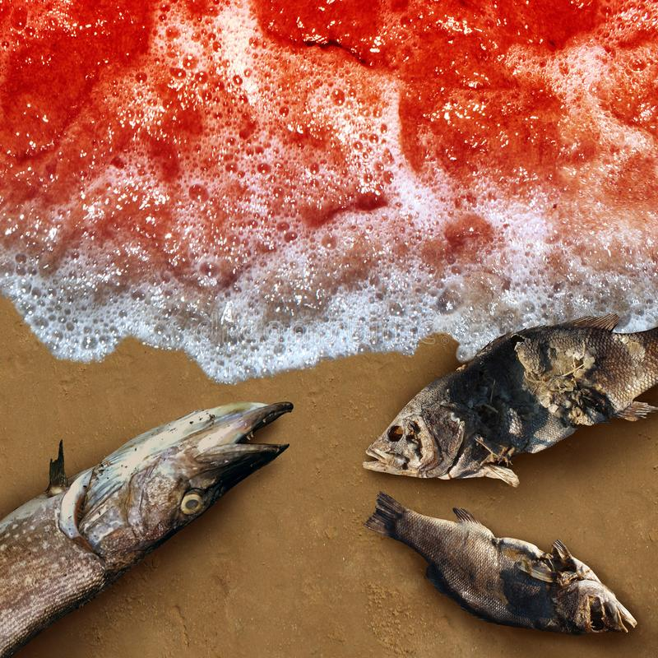
Fig. 1. Captions placed below their associated figure. One big time consuming problem in the last ICHA Proceedings was the quality of the images and the diverse formats we had, many lost quality went converted to pdf. I would suggest authors should include the figures in the template indicating were they should be inserted AND send figures separately in jpg files.

Fig. 2. XX, etc.

Include title at the top of the Table if helpful.
Year | LOCATION | Diversity Index
2021 | Caribbean Sea | 0.2
Table 1. Caption.
Do not send tables in figure format

Acknowledgements

References

Journal articles
Last name, E. and Last name, G. (2008). Abbreviated journal name 7, 159-178.
Last name, E.K., Last name, T.L., Last name, J. (2008). Abbreviated journal name; end with a period if last word in journal title is abbreviated 275, 2733-2741.
Last name, P., Last name, S.T., Last name, C.O., Last name, P.A. (2005). Abbreviated journal name 299, 137-148.
Last name, A., Last name, N., Last name, A., Tamminen, T. et al., (2011). Abbreviated journal name 10, 495-502.

Technical Reports
Report initials (2017). Report Title. Institution and location.

Conference citation
Last name, S., Last name, A., Last name, A. (2018). In: Last name, L.O. and Last name, Z.M. (Eds.), Proc. Conference name, Location, Country, pp. 22-25.
Book Chapter
Last name, G.R. (1978). In: Name(s), A. (ed.), Title. Press name, Location, pp. 191-196.
Book
Last name, S., Last name, A., Last name, A. (2018). Press name, 745 pp.

